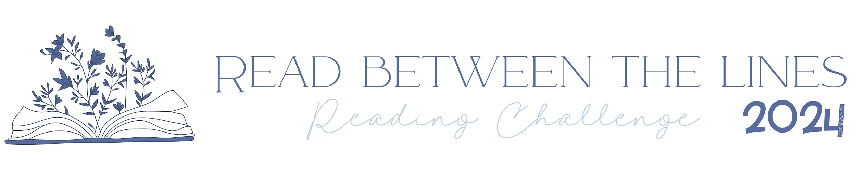

1. A Book Set in a Foreign Country
2. A Book About a Lost Love
3. Typographical Cover
4. A Book Written by a BIPOC Author
5. A Book That is Now a TV Series or Film
6. An Epistolary Novel
7. A Book About a Serial Killer
8. A Memoir
9. "Heart" in the Title
10. A Book You Would Reread (And Now Have)
11. A Book About Death
12. Set in a Bookshop or Library
13. A Magical Realism Book
14. A Book That Makes You Laugh
15. A Book by a Nobel Laureate
16. The Colour Blue on the Cover
17. A Book Published in 2024
18. A Shirtless Man on the Cover
19. A Graphic Novel
20. Set in Paris, France
21. A Book Given to You
22. A Book That Should Be Adapted for Screen
23. First Person Narrative
24. An Audiobook
25. A Book Involving a Journey
26. A Neurodivergent Character
27. LGBTQ+ Representation
28. The Word "Last" in the Title
29. A Non-Fiction Book
30. A Historical Novel
31. A Book You Meant to Read Last Year
32. An Illustrated Book
33. A Book from Reese's Book Club
34. An Alliterated Title
35. A Book With a Crown on the Cover
36. Set in China, Korea or Japan
37. A Booktok Recommendation
38. A Book That Has the Same Title as a Song
39. Over 500 Pages
40. A Library Book
41. A Book by a Favourite Author
42. A Controversial Book
43. A Cozy Mystery
44. A Number in the Title
45. A Young Adult Novel
46. A Book Set During a War
47. A Book with an Animal on the Cover
48. A Debut Novel
49. A Book by Kristin Hannah or Kate Quinn
50. A Translated Book